Nama Anggota Kelompok :  
❖ Mukhamad Furqon  
❖ Alwan Alyafi Mulyawan  
❖ Made Darma Wijaya  
❖ Frisca Febriyani K.  
❖ Sinta Kusuma

1. **Step-Step Melakukan Data Scraping pada E-Commerce**
2. Pilih keyword yang akan dicari misalnya “*laptop asus”*
3. Lalu kita buka website e-commerce contohnya Shopee
4. Pastikan Node JS dan Library Puppeter terinstall
5. Setelah itu *Inspect Element* pada bagian yang mau kita ambil datanya seperti judul postingan seperti digambar   
   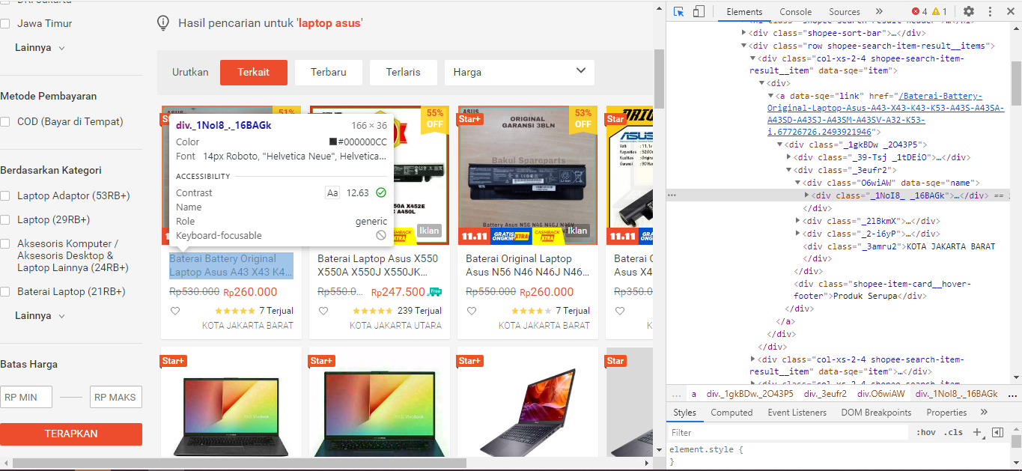
6. Masukkan kata kunci yang sudah didapat seperti judul postingan dan harga kita ambil text menggunakan “innerHTML()” serta untuk gambar kita ambil sumber nya menggunakan “src”  
   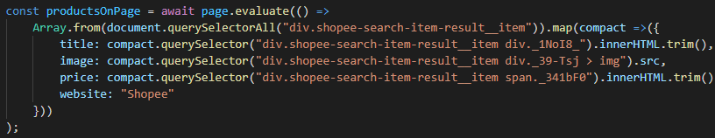
7. Selanjutnya pilih untuk menyimpan data tersebut, contohnya menggunakan database dan buat koneksi nya   
   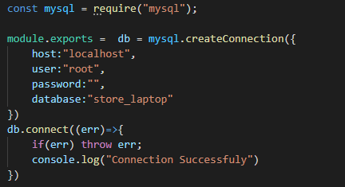
8. Jalankan script yang sudah dibuat tadi menggunakan command “node [*path file*]” seperti Digambar

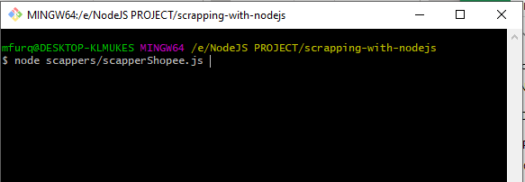

1. Setelah itu script akan berjalan dan melakukan scraping secara otomatis  
   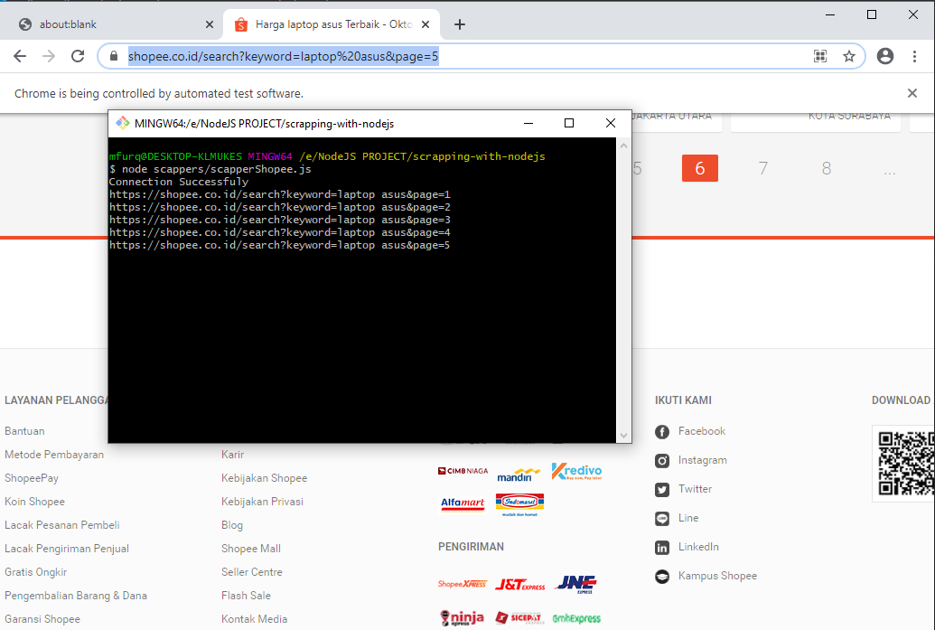
2. Lalu kita cek di database apakah masuk atau tidak data yang sudah kita scraping tadi  
   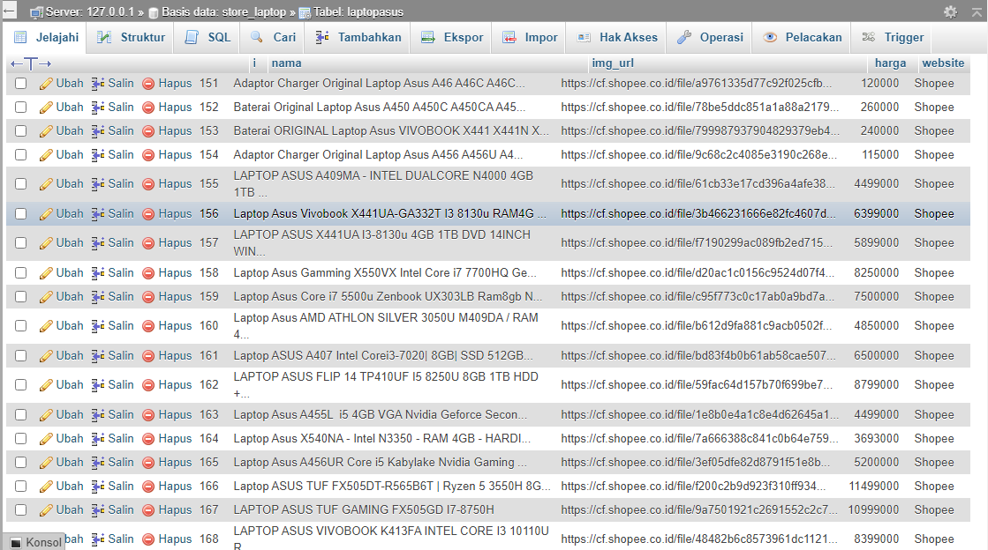
3. Terakhir mari kita tampilkan hasil data scraping tadi  
   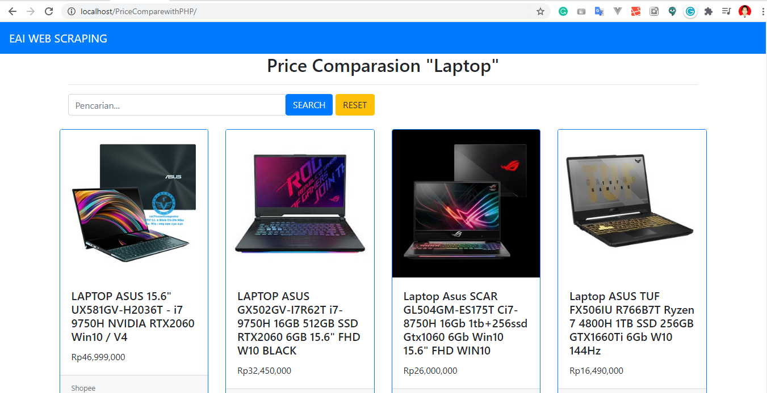
4. **Screenshot Source Code**
5. Source Code connection.js

**const** mysql = require("mysql");

module.exports = **db** = mysql.createConnection({

host:"localhost",

user:"root",

password:"",

database:"store_laptop"

})

**db**.connect((**err**)=>{

**if**(**err**) throw **err**;

console.log("Connection Successfuly")

})

1. Source Code scapperShopee.js

**const** puppeteer = require("puppeteer");

**const** mysql = require("../database/connection");

**async** **function** **autoScroll**(page){

**await** page.evaluate(**async** () => {

**await** **new** Promise((resolve, reject) => {

**var** totalHeight = 0;

**var** distance = 100;

**var** timer = setInterval(() => {

**var** scrollHeight = document.body.scrollHeight;

window.scrollBy(0, distance);

totalHeight += distance;

**if**(totalHeight >= scrollHeight){

clearInterval(timer);

resolve();

}

}, 100);

});

});

}

(**async** ()=>{

**const** keyword = 'laptop asus';

**const** extractProducts = **async** url=>{

**const** page = **await** browser.newPage();

**await** page.goto(url,{waitUntil:'networkidle0'});

console.log(url)

**await** page.setViewport({

width: 1200,

height: 800

});

**await** autoScroll(page);

**await** page.screenshot({path:'web.png',fullPage:true})

**const** productsOnPage = **await** page.evaluate(() =>

Array.from(document.querySelectorAll("div.shopee-search-item-result__item")).map(compact =>({

title: compact.querySelector("div.shopee-search-item-result__item div._1NoI8_").innerHTML.trim(),

image: compact.querySelector("div.shopee-search-item-result__item div._39-Tsj > img").src,

price: compact.querySelector("div.shopee-search-item-result__item span._341bF0").innerHTML.trim().replace('.','').replace('.',''),

website: "Shopee"

}))

);

**await** page.close();

**const** nextPageNumber = parseInt(url.match(/page=(\d+)$/)[1],10)+1;

**if**(nextPageNumber > 5){

**return** productsOnPage

}**else**{

**const** nextUrl = `https://shopee.co.id/search?keyword=${keyword}&page=${nextPageNumber}`;

**return** productsOnPage.concat(**await** extractProducts(nextUrl))

}

};

**const** url = `https://shopee.co.id/search?keyword=${keyword}&page=1`;

**const** browser = **await** puppeteer.launch({headless: false});

**const** dataProduct = **await** extractProducts(url)

**const** insertToDatbase = (dataProduct)=>{

**for** (**let** index = 0; index < dataProduct.length; index++) {

**const** data = dataProduct[index];

mysql.query("INSERT INTO laptopasus (nama,img_url,harga,website) VALUES(?,?,?,?)",[data.title,data.image,data.price,data.website],(err,rows,fields)=>{

**if**(err) **throw** err;

console.log("Insert Success")

})

}

}

console.log(dataProduct)

// insertToDatbase(dataProduct)

**await** browser.close();

})();

1. Source Code scapperBhinneka.js

**const** puppeteer = require("puppeteer");

**const** mysql = require("../database/connection");

**async** **function** **autoScroll**(page){

**await** page.evaluate(**async** () => {

**await** **new** Promise((resolve, reject) => {

**var** totalHeight = 0;

**var** distance = 100;

**var** timer = setInterval(() => {

**var** scrollHeight = document.body.scrollHeight;

window.scrollBy(0, distance);

totalHeight += distance;

**if**(totalHeight >= scrollHeight){

clearInterval(timer);

resolve();

}

}, 100);

});

});

}

(**async** ()=>{

**const** keyword = 'laptop asus';

**const** extractProducts = **async** url=>{

**const** page = **await** browser.newPage();

**await** page.goto(url,{waitUntil:'networkidle0'});

console.log(url)

**await** page.setViewport({

width: 1200,

height: 800

});

**await** autoScroll(page);

**await** page.screenshot({path:'web.png',fullPage:true})

**const** productsOnPage = **await** page.evaluate(() =>

Array.from(document.querySelectorAll("div.bt-product-catalog-item")).map(compact =>({

title: compact.querySelector("div.bt-product-catalog-item__title > p").innerHTML.trim(),

image: compact.querySelector("div.bt-product-catalog-item__image > img").src,

price: compact.querySelector("p.bt-product-catalog-item__price-normal").innerHTML.trim().replace("Rp","").replace('.','').replace('.',''),

website: "Bhinneka"

}))

);

**await** page.close();

**const** nextPageNumber = parseInt(url.match(/page=(\d+)$/)[1],10)+1;

**if**(nextPageNumber > 5){

**return** productsOnPage

}**else**{

**const** nextUrl = `https://www.bhinneka.com/jual?cari=${keyword}&page=${nextPageNumber}`;

**return** productsOnPage.concat(**await** extractProducts(nextUrl))

}

};

**const** url = `https://www.bhinneka.com/jual?cari=${keyword}&page=1`;

**const** browser = **await** puppeteer.launch({headless: false});

**const** dataProduct = **await** extractProducts(url)

console.log(dataProduct);

**const** insertToDatbase = (dataProduct)=>{

**for** (**let** index = 0; index < dataProduct.length; index++) {

**const** data = dataProduct[index];

mysql.query("INSERT INTO laptopasus (nama,img_url,harga,website) VALUES(?,?,?,?)",[data.title,data.image,data.price,data.website],(err,rows,fields)=>{

**if**(err) **throw** err;

console.log("Insert Success")

})

}

}

console.log(dataProduct)

insertToDatbase(dataProduct)

**await** browser.close();

})();